Prince of Peace
THE BELLS
NOVEMBER 2024
Inside this issue:



Thanksgiving & Honor

in Egypt. All of the festivals & feasts that God commanded Israel to have pointed to Christ & His redemptive work that freed us from the bondage of sin, death, & Satan’s power. The festivals & feasts also pointed to the marriage feast of the Lamb in God’s Kingdom at the end of time.
In the Book of Revelation, we see the celebration of the final victory & the continual praise & honor given to God – Father, Son, & Holy Spirit by all of those who are saved in Christ. It is a glorious celebration that will last for all of eternity. But the celebration has already started. In the Book of Revelation, we see all the saints; past, present & future around the throne of God with angels, archangels & all the company of heaven praising God. Because John records the words of the heavenly praise, the Christian Church here on earth can join in now with all of heaven worshiping, honoring, singing praises to God & thanking Him for our salvation in Christ. Every time we celebrate the Lord’s Supper in the Divine Worship, it’s a glorious day of Thanksgiving in which we eat the flesh of the Lamb of God, Jesus Christ, & drink His blood as He commands us to do in His new covenant.
In the Lord’s Supper, all the inhabitance of heaven & earth join together in celebration of Christ’s redemptive work. All of our loved ones who have died in the faith celebrate with us too. It’s a foreshadowing of the feast to come in which we will celebrate with all the company in heaven in a new world that will never end. We owe God all of our thanks, praise, honor, & worship for the abundant blessings He has given to us every day. God provides for all of our
Servants in Ministry | 3
Birthdays and  Anniversaries | 4
The Lutheran Hour | 7
Calendar | 11

“Amen! Blessing and glory and wisdom and thanksgiving and honor and power and might be to our God forever and ever! Amen.”
Revelation 7:12

Thanksgiving Day is quickly approaching. It is a day on which we eat, drink, watch football & spend time with family & friends. We attribute the Thanksgiving holiday with the harvest feast between the pilgrims & the Indigenous people of America. But in the Old Testament God had established several festivals & feasts around the harvest. It was a time in which Israel would gather, thank & praise God for the bountiful harvest, & remember how God had released His people from the bondage of slavery in

1
WORSHIP WITH US
Sunday:
10:15AM

Contact us:
princeofpeacefreedom.com

Office 724.728.3881

Preschool 724.728.2405

Fax 724.728.6708

Email
Pr. Sean Walters
pastorseangw@gmail.com

Twila DeThomas
popluthsecy@comcast.net

Preschool
popreschool@comcast.net

needs of body & spirit. Everything we have is from His good & gracious hands. Hands that were nailed to the cross so that we can be free from sin & death.
We shouldn’t be thankful to God for just one day out of the year, but every day because God blesses us every day. Each Sunday is a mini-Easter celebration & the Lord’s Supper is a celebration of the salvation that Christ has won for us. So, let us give thanks as Christ did on that Holy Thursday evening when He prayed, “Blessed are You, Lord our God, Ruler of the universe, who brings forth bread from the earth.” And “Blessed are You, Lord our God, Ruler of the universe, who creates the fruit of the vine.”
Paul reminds us that we are participants in the Lord’s Supper & one in Christ. He wrote, “The cup of blessing that we bless, is it not a participation in the blood of Christ? The bread that we
(cont.on page 2)



 Allen’s cousin, Ima Gene Patrick Donnelly, stroke
Hoby’s Father-in-Law, Bob, 
Jack Hogue, parkinson’s disease, 
 Kristy, kidney failure Elizabeth
Jean Taylor’s brother Don, kidney cancer
 Jessica, colon & liver cancer Colleen McCormick Lambert, terminal cancer
Edward Cramer, Stage 4 stomach cancer Dee, health issues
Willis Voland & family
Skylar DeThomas Terry DeThomas
Whalen Family

(cont.from page 1)

break, is it not a participation in the body of Christ? Because there is one bread, we who are many are one body, for we all partake of the one bread.” (1 Co 10:16-17) We are one in Christ Jesus & together with all of heaven we forever give thanks & praise to our God for all that He has done, is doing, & will do for His creation. Every day is Thanksgiving Day in the kingdom of God. So, let us join together & sing, “Amen! Blessing and glory and wisdom and thanksgiving and honor and power and might be to our God forever and ever! Amen.” (Rev 7:12)
Pastor Sean Walters



CHRISTMAS DECORATING AND POTLUCK LUNCH
December 1st following service
See Linda Weimer with any questions

3
NOVEMBER Servants in Ministry

ACOLYTES

11/03 Grace Shibata
11/10 Brooke Lehman
11/17 Joy Shibata
11/24 Jesse Dietrich

READERS

11/03 Hoby Schweikert
11/10 Karl Borgman
11/17 Tammy Eckstrom
11/24 Bob Licht
ALTAR GUILD

LINDA WEIMER
GREETERS

11/03 Janet Holland/Linda Weimer
11/10 OPEN
11/17 OPEN
11/24 OPEN


Advent Services
December 4 @ 7PM
December 11 @7PM
December 18 @7PM



Tara Dulski 11/07
Amy Rachuba 11/14
Joleen Mesing 11/16
James Shibata SR 11/22
Craig Genser 11/27
Beau DeThomas JR 11/30



No anniversaries this month

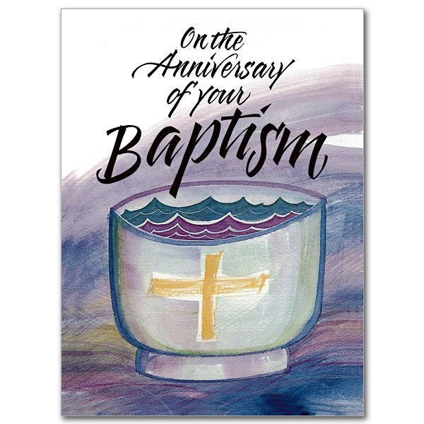

Robert Rachuba 11/09
Tamara Eckstrom 11/16
Joleen Mesing 11/22

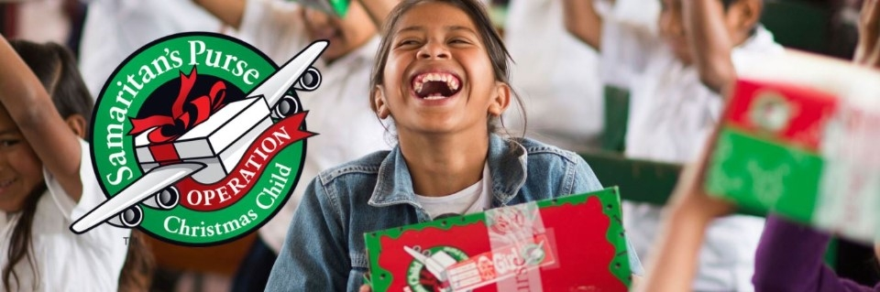

Operation Christmas Child
Shoebox Packing Party

Saturday, November 16th @ 5PM
pizza will be served

4

Hope and Healing Through the Holidays
A Holiday Grief Workshop hosted by Good Samaritan Hospice
Saturday, Nov. 9
9 a.m. - 12 p.m. Middlesex Office Location



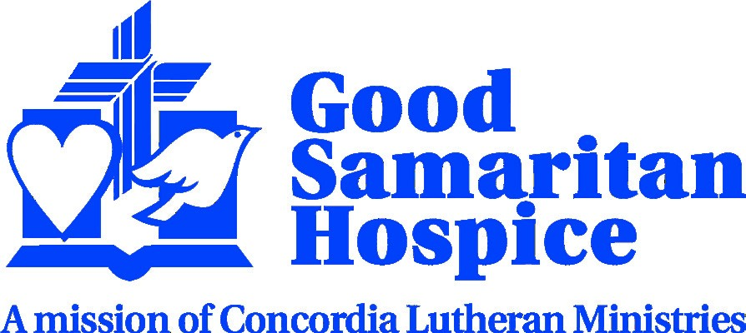
116 Browns Hill Road, Valencia, PA 16059
www.good-samaritanhospice.org
•
1-800-720-2557
The event will provide guidance and support to help individuals cope during the holiday season after the loss of a loved one and will include a craft. Attendees are encouraged to bring photos of their loved or mementos for this craft.
Breakfast will be provided. All ages are welcome, and special breakout sessions with age-appropriate activities will be held for youth. All children must be accompanied by an adult.
Walk-ins are welcome, but registration is strongly encouraged by Nov. 4.
For more information or to register call 1-800-720-2557.

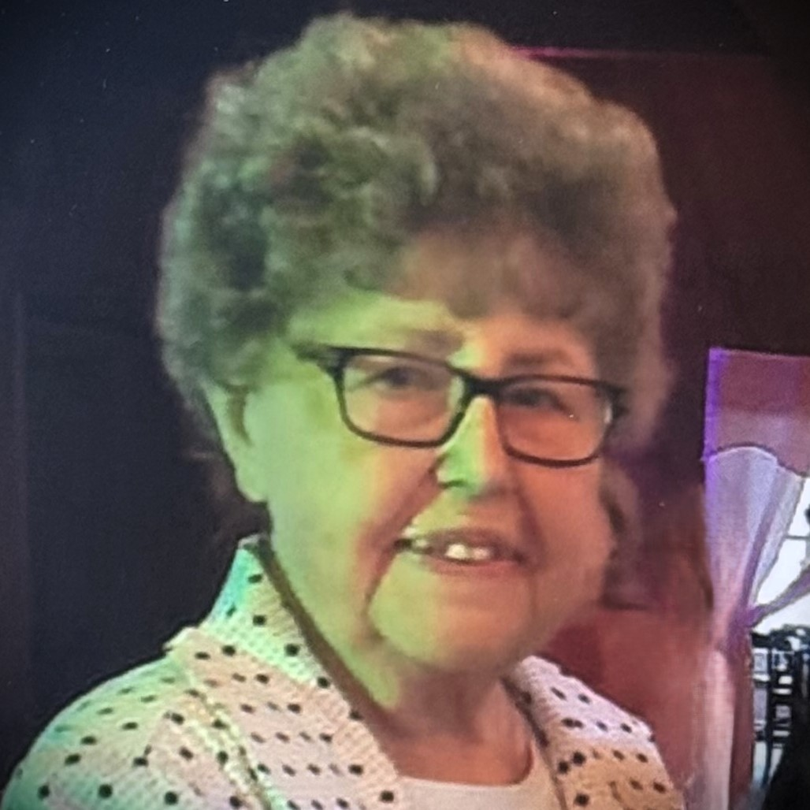

Katherine Elizabeth Voland
January 24, 1936 - October 22, 2024

Born January 24, 1936 in Pittsburgh, PA passed from this life surrounded by those who loved her, into her Lord’s presence on October 22, 2024.
Kathy is survived by her husband of nearly 70 years, Willis E. Voland Jr. and together they began their life story with, as Kathy always called them, her “3 Perfect Sons.” She was deeply devoted to and very proud of her sons, David W. Voland (Susan), Donald K. Voland (Deborah d), Craig E. Voland (Lorie).
Her sons gave her 9 grandchildren, 18 great grandchildren and 1 great-great-grandchild. All of whom she loved dearly. Never forgetting a single birthday and always with a card with a dollar bill inside, no matter how old they were.
Kathy’s dream as a young woman, just graduating high school was to become a nurse, and she held onto that dream until her sons were old enough to help care for themselves and then she accomplished that dream of becoming an LPN. She was a kind, caring and some would say, a no-nonsense nurse. She worked for many years in both a hospital and the nursing home setting and was most compassionate to those needing a gentle touch and some conversation.
In her daily life outside of nursing she enjoyed cooking and baking, always searching for new recipes to try out on her children and grandchildren. She loved sewing and crafts; she loved planting flowers in her garden, planting her favorite flower which was the simple daisy. And Kathy collected chickens. Little chicken Knick knacks could be found all over her home, in every room through the years, as her collection grew, Kathy’s chickens became quite the topic of conversation at family gatherings. Everyone wondered who would inherit this collection someday, and there was much laughter as we nominated anyone who was not present at dinner that day. Kathy would be happy to know that those chickens now reside in the homes of her children and grandchildren. Even traveling as far as Germany where they will always be a reminder of her and the many family gatherings.
Along with her children, grand and great grandchildren, she was loved by her sister Carole Trakoval (Robert d), of NY, the late Mary Lou Nock (Frank), the late Edward Johe (Anne d) and the late Olga McFarland (Howard d), and many nieces and nephews.
Kathy faithfully attended and in her younger years, was a very involved member of Prince of Peace Lutheran Church in Freedom, PA. Her favorite song was Jesus Loves Me.
In lieu of flowers, memorial contributions may be made to Price of Peace Lutheran Church.
6



Station | City, State | Freq | Band | Day | Time
WWCH | Clarion, PA | 1300 | AM | Sun | 7:30 AM
WWNL | Pittsburgh, PA | 103.9 | FM | Sun | 3:30 PM
WWNL | Pittsburgh, PA | 103.9 | FM | Tue | 12:30 PM
WWNL | Pittsburgh, PA | 1080 | AM | Sat | 3:30 PM
WWNL | Pittsburgh, PA | 1080 | AM | Tue | 12:30 PM

November 2024
November 3
"Working the System"
Lutheran Hour Speaker: Rev. Dr. Michael Zeigler
God's Law--a "system" that keeps the world from flying apart while it also shows us we need the Savior Who came to live, suffer, and rise for us.
(Genesis 33:8)
November 10
"My Name Is Now Yours"
Guest Speaker: Rev. Dr. Daniel Paavola
God comes to renew us with His forgiving love, rename us in Baptism, and remain with us through His Word.
(Genesis 35:10-11)
November 17
"Album-Worthy"
Lutheran Hour Speaker: Rev. Dr. Michael Zeigler
If everything you've ever thought or done was captured in a photo, how many of them would you save for all to see? Hear how God redeems all our snapshots--even those that don't seem "album-worthy."
(Genesis 35:3)
November 24
"Jesus Sees What's in the Heart"
Guest Speaker: Rev. Dr. Hector Hoppe
Jesus sees what's in our hearts. What's in His heart? God saw that we needed a Savior.
(Mark 12:41-44)
7



NOVEMBER
This is a monthly prayer guide for your daily use. Each day as you pray, please feed your Mite Box in support of district and LWML Mission Grants. As you lift up the countries and mission grants listed, pray that the Gospel of our Lord Jesus Christ would be heard by those who live there or are served by our mite offerings.
Each country listed has been a recipient of a mission grant from Lutheran Women in Mission at some time since 1942. What a joy it is to bring these prayers to our Father’s listening ears!

- For thanksgiving for all the saints who have gone before us.
- For LWML Mission Grant #26.
- For the day of activity and the night of rest.
- For The Sudan, one of the 83 countries supported by an LWML grant.
- For those in elected offices.
- For the Lutheran Women in Mission Treasurer.
- For the country of Taiwan.
- For the LWML Iowa West District.
- For thanksgiving of God’s goodness and love.
- For the country of Tanzania.
- For those who have served in the Armed Forces.
- For the opportunity to give thanks through song.
- For medical researchers.
- For church camps.
- For the country of Thailand.
- For the LWML Iowa East District.
- For school students.
- For the country of Pakistan.
- For the peace that only God can provide.
- For teachers and those studying to be teachers.
- For LWML Mission Grant #27.
- For those who provide transportation for others.
- For the country of Togo.
- For those mourning a loss.
- For the opportunity to profess God’s name.
- For the country of Turkey.
- For those who might not have a bountiful Thanksgiving meal.
- For the blessings given by the Lord.
- For the North Wisconsin District.
- For the country of Uganda.

Lutheran Women in Mission | lwml.org Mite Prayer Calendar

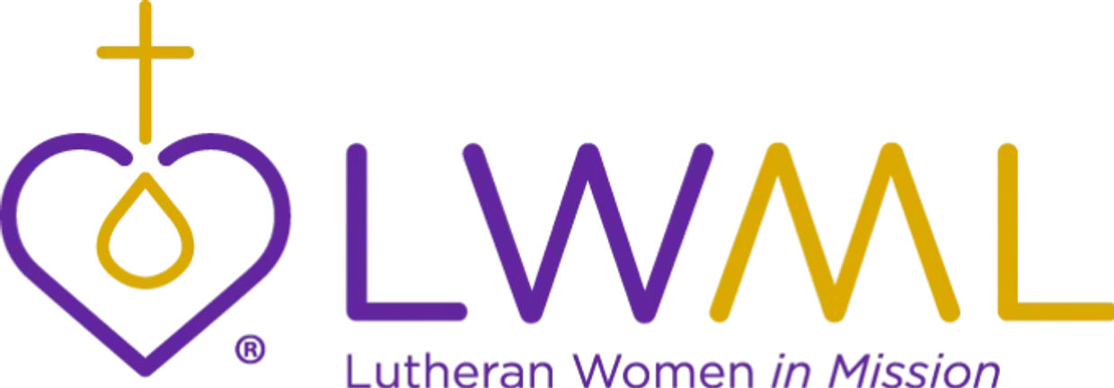

2023–2025 Mission Grants
1. Orphan Grain Train Servant Center — Orphan Grain Train, U.S. $100,000 — PAID IN FULL
2. A Healing Space for At-Risk Children — Dakota Boys and Girls Ranch, ND $100,000 — PAID IN FULL
3. Serving God's Children with Special Needs — Journeys Lutheran School, Milwaukee, WI $100,000 — PAID IN FULL
4. Fortifying Faith in Those with Vision Impairment — Lutheran Braille Workers $100,000 — PAID IN FULL
5. Disaster Response Team — Trinity Lutheran Church, Tyler, TX $50,000 — PAID IN FULL
6. Mobile Kitchen — Forged by Fire Services, Gulf Coast Region, U.S. $85,000 — PAID IN FULL
7. Upheld by God's Hand, Mental Health Outreach — LCMS Life Ministry $96,500 — Partial payment of $48,250
8. Expanding Gospel Proclamation Worldwide — Concordia Seminary, St. Louis, MO $100,000
9. Equipping Young Leaders — LCMS Youth Ministry $50,000 — Partial payment of $25,000
10. Set Apart To Serve — LCMS Office of Pastoral Education $100,000 — PAID IN FULL
11. Lutheran Women in Mission Finish the Job — Ministry in Mission, Haiti $85,000 — PAID IN FULL
12. Sharing Christ Crucified with High School Youth — Lutheran High School of Greater New Orleans, LA $35,000 — PAID IN FULL
13. Water and the Word — Evangelical Lutheran Church in Kenya $80,000 — PAID IN FULL
14. Enhancement of Deaf Ministry and Outreach — Ephphatha Lutheran Mission Society, U.S. $47,000
15. Feeding Haitian Children Through Gospel and Meals — Trinity HOPE $58,082 — PAID IN FULL
16. Care for Street Children of Western Kenya — Capstone Ministries $50,000 — Partial payment of $28,418
17. Nurturing Faith for the Aging — Lutheran Ministries Media (Worship Anew) $100,000
18. Zoe's Home Support — Zoe's Home, Trinity Lutheran Church, Clinton, MO $75,000 — Partial payment of $25,000
19. Tanzania Children's Homes — Evangelical Lutheran Church of Tanzania, Africa $74,500 — PAID IN FULL
20. Sharing Christ with Women and Children in Kazakhstan — Lutheran Hour Ministries $100,000 — Partial payment of $50,000
21. Healthy Together: Healthy Workers, Healthy Church — Lutheran Family Services, U.S. $106,000 — PAID IN FULL
22. Expanding Gospel Outreach to Hispanics in U.S. — Lutheran Hour Ministries $100,000 — Partial payment of $50,000
23. A Legacy of Love for Special Needs Children — Lutheran Special Education Ministries, U.S. $100,000 — Partial payment of $50,000
24. God's Word for Central and South American Missions — Lutheran Heritage Foundation $100,000 — PAID IN FULL
25. Bringing God's Word to India — India Bible Translation Project $100,000 — Partial payment of $74,019 — Featured
26. Life Connection Events and Kits — Lutherans for Life $70,000
27. Siouxland Lutheran Hispanic Ministry — Hope Lutheran, South Sioux City, NE $50,000
28. Growing Our Place: Care for Special Needs Students — Our Place After School Care, Inc., NE $20,000 — PAID IN FULL
29. Repairs for St. Paul's Lutheran School — St. Paul Lutheran School, Cullman, AL $50,000 — PAID IN FULL
30. Showering Love on the Least of These —Mercy Holistic Ministry, CA $100,000 — Partial payment of $50,000
31. PARTIAL Breaking Generational Poverty in Detroit — Camp Restore Detroit, MI $58,988.62 — PAID IN FULL
9


All your children shall be taught by the Lord, and great shall be the peace of your children. –Isaiah 54:13

The month of October was very busy! First, we celebrated Fire Safety during the month of October. Our three year old classes received a special visit from some of New Sewickley Fire Dist. own volunteer fire fighters and their fire engines to learn some fire safety tips. Our four year old classes got to go on a field trip to New Sewickley Fire Dist., the old Big Knob fire station to see the fire house first hand and squirt a fire hose as well as crawl through a pretend burning house. The fire department even provided a safety packet with a coloring book and crayons.
All preschool classes took a fieldtrip to Yeck’s Pumpkin Patch at Yeck’s Farm to take a hay ride and play in the sun. The parents escorted their students for our trip and played in the many amenities Yeck’s has to offer. Rounding out the morning, we had a snack and each student received a pumpkin and activity bag full of goodies. Thank you Yeck’s Farm!
We added three new letters to our writing skills this month; A, O, and H. During letter A week, we focused on apples and the many kinds that grow. We also tasted three kinds of apples and how they taste. The general consensus is that students choose red delicious apples over Granny Smith or Gala.
Letter O week was a discussion about October as we started creating Halloween arts and crafts. Our four year old class did a fun science experiment with pumpkins. We tested whether a pumpkin will sink or float in water. We made a hypothesis and then followed through to find our actual answer. No matter how big or small a pumpkin is, it will always float in water; unless it is cut or hollowed out.
Finishing out the month we focused on the letter H. The letter H represented Halloween and the fun school day. A special “Thank you” goes out to the wonderful parents for providing goodies and facilitating the Halloween party for the students.

We would like to wish everyone a safe and healthy Halloween if you choose to participate with trick or treating.

Until Next Month, May God Bless each and every one of you!
Mrs. Smith, Ms. Twila, and Ms. Michelle
10


Sun. | Mon. | Tue. | Wed. | Thurs. | Fri. | Sat.
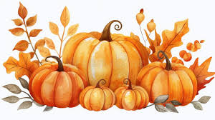 |  |  |  |  | 1 | 2
3 Pentecost 24  9AM Sunday School  10:15  Holy Communion | 4 | 5 | 6  NO Bible Study | 7 | 8 | 9  MEN’S  & WOMEN’S GROUPS  5:30 - 7
10 Pentecost 25  9AM Sunday School  10:15  Holy Communion | 11  Council  Meeting  6:30 | 12 | 13  11:00 Midweek Bible Study | 14  Choir Rehearsal  7PM   | 15 | 16  OCC  SHOE BOX PACKING PARTY  5PM
17 Pentecost 26  9AM Sunday School  10:15  Holy Communion | 18 | 19  | 20  11:00 Midweek Bible Study | 21  Choir Rehearsal  7PM | 22 | 23  
24 Last Sunday of the Church Year  9AM Sunday School  10:15  Holy Communion | 25 | 26 | 27  11:00 Midweek Bible Study  Thanksgiving Eve Service  5:30PM | 28  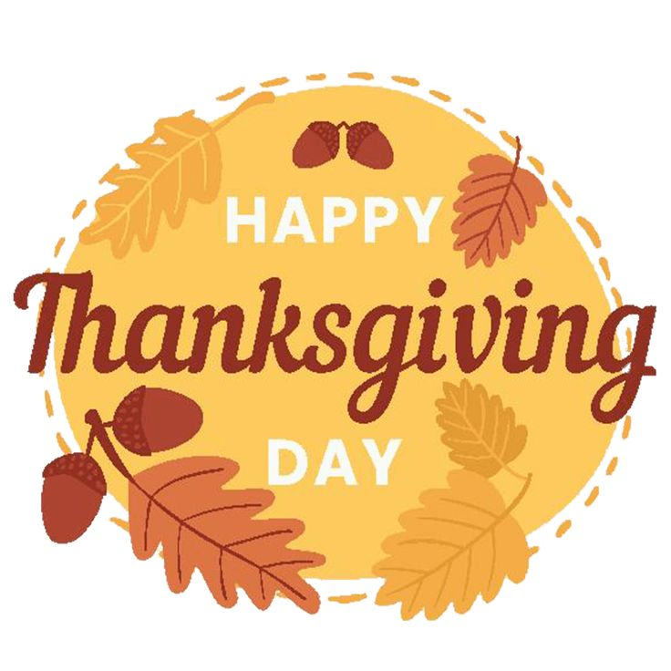 | 29 | 30
11

